**Overview:** This module will help you to customize OOTB SXA breadcrumb to insert a page in between the breadcrumb. For example, in your commerce site, you have a Product Listing page, that you want to include in your breadcrumb list of category and product, then you can add this with this package. Following are the steps, you need to follow.

1. Create a new base template under Foundation and name it _catalogrootitem and add a new field for root item like this.

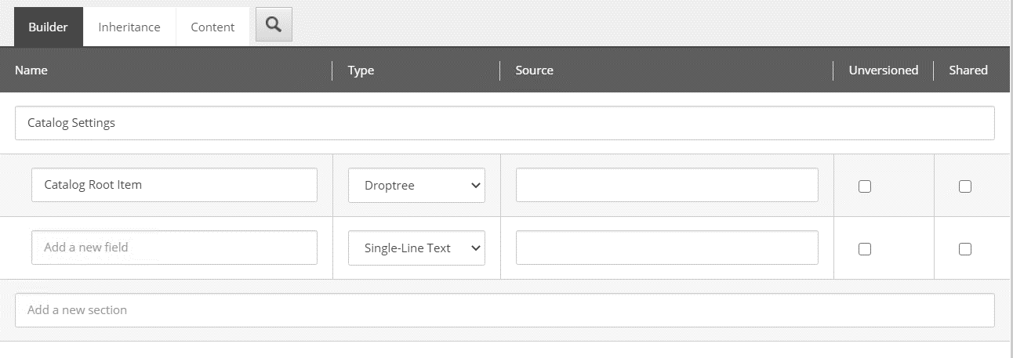

1. Inherit it in your Setting template item like this.

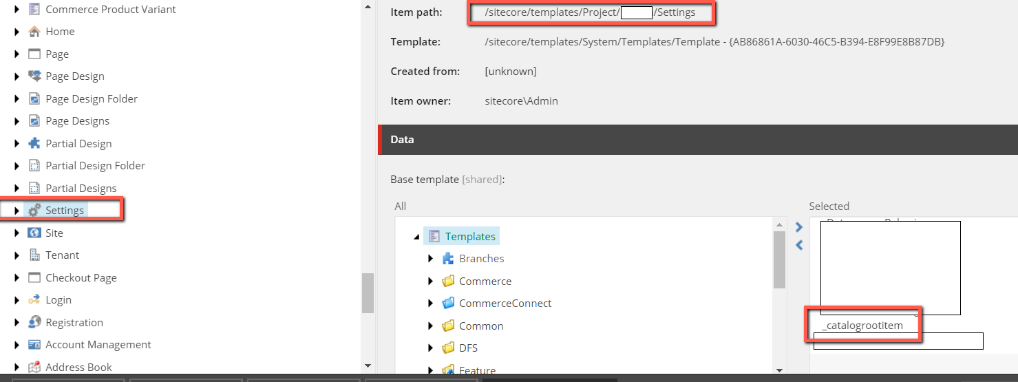

1. Now go to Setting item under your site and select a page that you want to include in it.

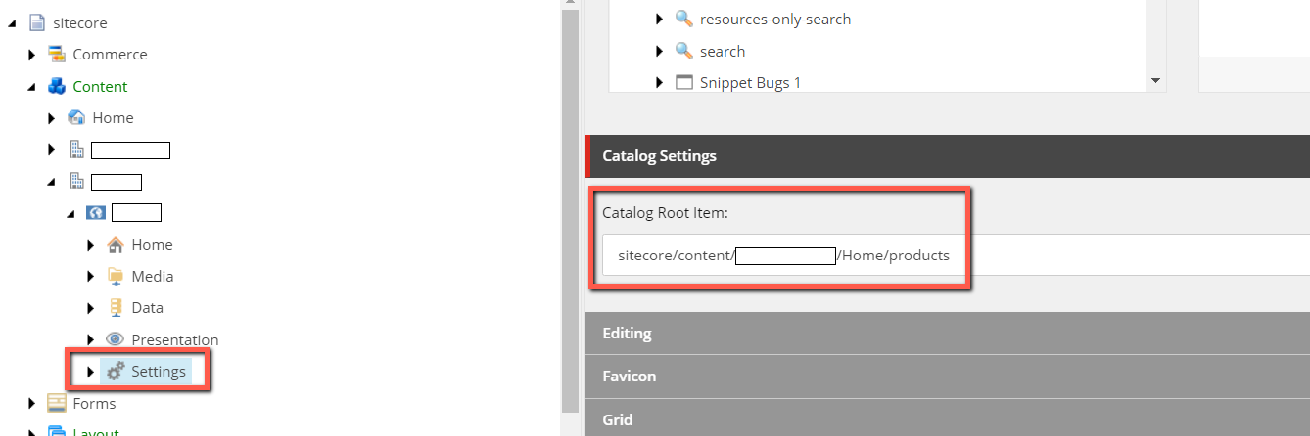

1. Install the attached package and it will add this root item in your breadcrumb like this. .

